MGT 40750 – Quantitative Decision Modeling Spring 2015

**End-of-Class Exercises: Reservation Management**

Name: _______________________________

Consider the following variation of the reservation management example discussed in class: In this problem, the airline would like to minimize its total cost which consists of both cost of lost sales and cost of bumping. Lost sales occur when consumer demand is higher than the number of tickets sold while bumping occurs when there are more passengers wanting to board than the available seats.

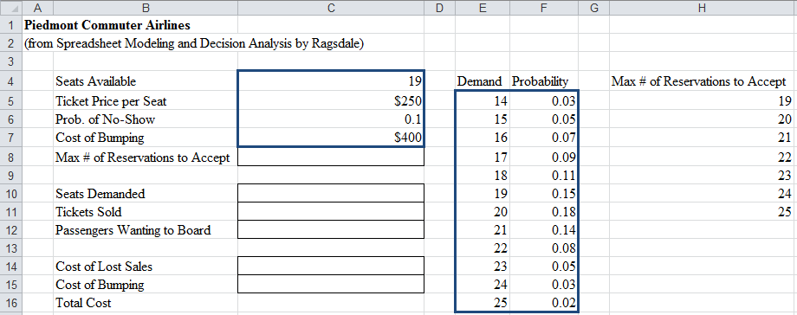**Step 1:** Specify your simulation model below:

=RiskOutput()+C14+C15

**Step 2:** Run your @Risk model. Based on the simulation results, what’s the optimal maximum # of reservations to accept?